

**LA GRANDEE INTERNATIONAL COLLEGE**

**Simalchaur, Pokhara, Nepal**

**A Project Proposal/Report**

on

**“Futsala”**

**Submitted to**

Bachelor of Computer Application (BCA) Department

LA GRANDEE International College

In partial fulfillment of the requirements for the degree of Bachelor of Computer Application under Pokhara University

**Submitted by**

Deepak Chhantyal (2021-1-53-0349)

Pawan Poudel (2021-1-53-0357)

Roshan Adhikari (2021-1-53-0363)

Bachelor of Computer Application, 8th Semester

Date: September 25, 2025

**Table of Contents**

1. Introduction 1

2. Background Study 2

2. Problem Statement 3

4. Objectives 4

5. Methodology 5

6. Project Gantt Chart 6

7. Deliverables 7

8. References 8

# Introduction

Futsal has become one of the most popular indoor sports, especially in urban areas. However, booking futsal courts is still mostly done through phone calls, social media messages, or physical visits, which often leads to confusion, wasted time, and scheduling conflicts. This project focuses on creating an Android-based futsal booking application that allows players to view available courts, check schedules in real time, and make quick reservations. For court owners, the app will provide an easy platform to manage reservations, update availability, and track bookings.

The project is important because it digitizes the traditional booking process, reduces errors, saves time, and ensures both players and futsal owners benefit from a more transparent and convenient system. With the rising use of smartphones and mobile payments, such an application is timely and relevant. By implementing the online booking system (Hasan, 2014) develop on the mobile app for the easier convenience.

# 2. Background Study

The popularity of futsal has grown rapidly, especially in urban areas, leading to high demand for courts and better booking management systems. Currently, most bookings are done through phone calls, social media, or in-person visits, which often cause scheduling conflicts, double bookings, and inconvenience for both players and court owners.

There are already sport venue booking platforms in Nepal such as Yakplayo (YakPlayo, 2025) and Vakundo that have mobile applications that enable their users to search, view futsal venue slots, book and use local wallets. Most of them, however, remain lack an ultra-slick mobile-first experience custom-made to futsal players. A futsal application must aim at: enabling users to locate courts in their area, see real-time availability, reserve and pay in-app with local gateways (e.g., eSewa, Khalti), allow hosts to be helpful and supportive with slot management and cancellations, and simple community features (teams, matches, ratings) to bridge the gap between court booking and actually organizing games.

This project aims to overcome these limitations by developing an Android-based futsal booking application with real-time slot management, conflict-free reservations, and a user-friendly interface. This ensures convenience for players and efficient court management for owners.

# Problem Statement

The some problems are:-

1. The current futsal booking process is manual, relying on phone calls, messages, or in-person visits.
2. This causes scheduling conflicts, mismanagement, and inconvenience for both players and court owners.
3. There is a lack of a dedicated Android-based futsal booking app that ensures real-time availability, prevents double bookings, and integrates local payment systems.

# 4. Objectives

The main objective of this project is to design and develop an Android-based futsal booking application that simplifies the process of searching, reserving, and managing futsal court bookings.

Overall objectives of this project include:

1. To develop an Android-based futsal booking application with real-time slot availability and instant booking confirmation.
2. To provide an easy-to-use interface for players to search, book, and cancel reservations.

# 5. Methodology

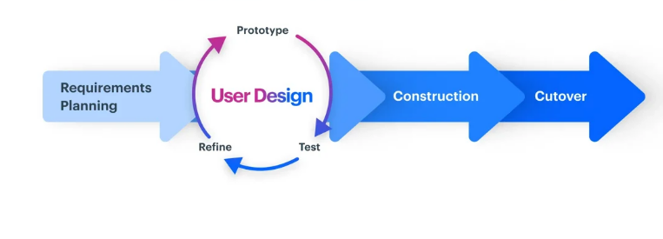

Figure 5.1: RAD model

The RAD (Rapid Application Development) (Team, 2025)is one model of software development life cycle (SDLC) model that focuses on rapid development and prototyping and incorporates the user in all stages.

The Stages are

* 1. Requirement Planning

Build A mobile app for players to book futsal ground and an admin panel for owners to manage bookings.

* 1. User Design (prototyping)

Create quick UI mockups, Dashboard layout. Test the prototype.

* 1. Construction

Develop actual model such as mobile app, backend, database, features like authentication, booking system, admin controls.

* 1. Implementation

Beta test with a few futsal grounds and player. Fix bugs and optimize performance.

# 6. Project Gantt Chart

The Gantt Chart outlines the timeline and major tasks for the development of the futsal Booking app, showing the schedule, duration and sequence of activities.

# 7. Deliverables

The key deliverables of this project include:

1. A fully functional Android-based futsal booking application with real-time slot availability and booking features.
2. Delivering features such as booking history, match schedules, and contact information for easy access.

# 8. References

Hasan, S. M. (2014, November). *Documentation of online booking system*. Retrieved from https://www.researchgate.net/publication/275097517_DOCUMENTATION_OF_ONLINE_BOOKING_SYSTEM

Team, K. (2025, August 11). *Rapid Application Developemnt*. Retrieved from What is Rapid Application Development (RAD)? An Ultimate Guide for 2025

YakPlayo. (2025, September 25). Retrieved from YakPlayo - Sports venue booking & team management: https://yakplayo.com/